**UNIVERSITY OF GREENWICH**  
COMP1649 – Human Computer Interaction Design

Coursework

|  |  |
| --- | --- |
| Student name | Huynh Phan Thai |
| ID number (00xxxxxxx) | 001353466 |
| Lecturer/Tutor name | Tran Thi Kim Khanh |
| Student submission date | November 24, 2023 |

Table of Contents

**I.** **Introduction** 4

**II.** **Background literature** 4

**1.** **Human-Computer Interaction Research (HCI research)** 4

**2.** **HCI Theory** 7

**2.1** **Cognitive Psychology** 7

**2.2** **Interaction Design Theory** 7

**2.3** **Modes of Interaction** 8

**2.4** **Types of Interaction** 8

**2.5** **Design Principles** 9

**2.6** **Design Pattern** 10

**3.** **Design Process** 11

**3.1** **Conceptual Design** 11

Metaphors 12

**3.2** **Design principles** 13

**4.** **Prototype** 19

**4.1** **Phycical prototype** 19

**4.2** **Low-fidelity Prototype** 20

**4.3** **Mid-fidelity Prototype** 21

**5.** **Research Study** 45

**6.** **Conclusion** 55

References 56

**Appendices** 57

**Table of figures**

Figure 1 Diving logbook-Dive Number (Dykusha, 2021) 4

Figure 2 Garmin Dive™ (Garmin, 2020) 6

Figure 3 Hierarchical Model 11

Figure 4 Conceptual Model 12

Figure 5 Visibility 14

Figure 6 Register successful 15

Figure 7 Add track successful 16

Figure 8 Constraints 17

Figure 9 Consistency 18

Figure 10 Affordance 19

Figure 11 Phycical prototype 20

Figure 12 Low-fidelity Prototype 21

Figure 13 Main page 22

Figure 14 Flash screen 23

Figure 15 Register 24

Figure 16 Home page 25

Figure 17 TrackPage 26

Figure 18 Add Track 27

Figure 19 Add Track(2) 28

Figure 20 Update Track(1) 29

Figure 21 Update Track(2) 30

Figure 22 Delete Track 31

Figure 23 View Track 32

Figure 24 Record 33

Figure 25 Record((2) 33

Figure 26 Take a photo 34

Figure 27 View picture and video 35

Figure 28 Delete 36

Figure 29 View detail picture or video 37

Figure 30 Search normal 38

Figure 31 Search advanced scuba diving 39

Figure 32 Weather 40

Figure 33 Profile 41

Figure 34 Connecting 42

Figure 35 Terms and policies 43

Figure 36 Help 44

Figure 37 Logout 45

1. **Introduction**

The structure of the report includes four main parts: background documents, design process, prototype, and research. The basic document consists of two parts: human-computer interaction research, which provides an overview of your research literature on the project summary topic, and human-computer interaction theory, which briefly discusses relevant concepts and theories from the field of HCI. The design process includes conceptual design and design principles. Prototype briefly introduces and discusses the final mid-level prototype. A research study is proposed for a detailed (empirical) research study.

1. **Background literature**
2. **Human-Computer Interaction Research (HCI research)**

The diving application plays the role of managing the user's diving process, integrating utilities such as underwater photography and video recording. Users can know exactly the necessary parameters to avoid dangerous situations.

Some popular diving applications include: dive mate (scuba dive log), dive number, garmin dive™

Figure 1 Diving logbook-Dive Number (Dykusha, 2021)

DiveMate (Scuba Dive Log) (DiveMate, 2020)

Figure 2 Garmin Dive™ (Garmin, 2020)

Results after diving product research. I have learned the following:

When a person wants to go scuba diving, from amateur divers to professional divers, everyone needs a device to support their scuba diving trip. Users need to know the necessary indicators when scuba diving, from external indicators such as water temperature, amount of oxygen in the tank, depth, diving time to important internal indicators such as heart rate, body temperature. body and many other indicators. Besides, other amenities such as photography and video recording are also essential, helping to capture interesting moments under the sea.

As for the design, I created a user-friendly interface as follows:

The main functions will be located in the most visible place, the necessary functions and information can be identified by images to help users know the most effective information results. The colors of the application contrast, helping users not to confuse information with each other.

1. **HCI Theory**
2. **Cognitive Psychology**

Cognitive psychology in Human-Computer Interaction (HCI) uses cognitive psychology ideas and theories to create and assess computer systems and interfaces. It is concerned with comprehending mental processes such as perception, memory, learning, problem-solving, and decision-making.

**Memory**: Understanding how users encode, store, and retrieve information to design interfaces that support good information recall and reduce cognitive burden. For entertaining occasions, my design has preserved crucial information such as dive name, location, images, and videos.

**Perception**: Creating intuitive interfaces by examining how users perceive and interpret visual and audio information. In my design, the color of the indicators contrasts with the background color so it will not reduce the user's attention.

**Attention**: Increasing user engagement and task performance by acknowledging human attention's limited capacity and designing interfaces that prioritize relevant information. In my design, key functions like video recording, taking photos, adding a new diving have been highlighted, enhancing observability.

**Learning**: Facilitating user onboarding and skill acquisition by incorporating learning principles into interface design.

**Problem-solving and decision-making interface design**: Understanding how people approach problem-solving and decision-making processes to create interfaces that support these activities. In my design, there is a weather information component in the design that assists users in recognizing the weather in the most intuitive way.

**Feedback and Error Handling**: Errors are reduced by giving clear and timely feedback that is consistent with cognitive principles, assisting users in understanding the consequences. In my design page contains a lot of feedback on problems and successes to help users do the function as completely as possible. (Stuart K. Card, 2000)

1. **Interaction Design Theory**

In Human-Computer Interaction (HCI) and design, according to (Kanade, 2022)

Conceptual Model serves as an abstract representation illustrating the fundamental ideas and concepts underlying diving systems or equipment. This model is essential for creating an intuitive and user-friendly underwater interface.

Scuba Diving Prototypes involve the creation of preliminary versions of diving equipment for testing and evaluation. These prototypes, ranging from low to high fidelity, help designers explore ideas, demonstrate functionality, and gather feedback before full-scale production.

**Low-Fidelity** Dive Prototypes, such as hand-drawn sketches, wireframes, and mockups, provide cost-effective options for early-stage brainstorming and testing.

**Medium-Fidelity** Dive Prototypes, including clickable and interactive prototypes, offer a more realistic user experience by allowing divers to interact with various elements of the equipment.

**High-Fidelity** Dive Prototypes, such as functioning prototypes and simulations, represent the final diving gear. They are useful for testing performance and functionality in realistic underwater settings or simulating specific scenarios without requiring complete functionality.

I will introduce these parts in the "Prototype" section. (Jacko, Human-Computer Interaction. Novel Interaction Methods and Techniques, 2009) (Henderson, 2002)

1. **Modes of Interaction**

In the context of scuba diving, modes of interaction in Human-Computer Interaction (HCI) and design are crucial for facilitating seamless engagement between divers and underwater systems. The key modes tailored for the underwater environment include:

**Graphical User Interface** (GUI) with Dive Adaptation: underwater systems can be interacted with by divers using graphical elements that are intended to be visible and easily navigable in an aquatic setting.

**Dive Equipment Touchscreen Interaction:** allows touch gestures to be used to interact with specialist diving equipment, offering a responsive and easy-to-use interface for jobs that require submersion. In my design, the designs are primarily interactive on touch interfaces

**Voice Interaction Underwater**: enables voice commands or questions to be spoken to the system by divers, providing a hands-free means of communication while submerged.

**Gesture-Based Interaction for Divers**: this approach considers the difficulties and limitations of the underwater environment by allowing divers to interact with one other or with equipment by using gestures or movements.

**Haptic Engagement for Submersible Feedback**: described as providing touch feedback through vibrations or tactile sensations, improving the diver's awareness and communication when conventional visual or auditory cues are not present.

It takes a deep grasp of and dedication to these specialized interaction modes to design scuba diving interfaces that are in line with user preferences and the particulars of underwater exploration. This strategy guarantees that the technology blends in perfectly with the diving experience, improving underwater enthusiasts' overall enjoyment, safety, and communication. (Jacko, Human-Computer Interaction. Novel Interaction Methods and Techniques, 2009)

1. **Types of Interaction**

Human-Computer Interaction (HCI) involves the design and use of computer technologies, focusing on the interfaces between people and computers. Various types of interaction exist in HCI, including Command-Line Interaction, where users input text commands, and Graphical User Interface (GUI) Interaction, where users interact with visual elements. These interactions cater to different user preferences and levels of expertise.

**Instructing**: Instructing involves providing explicit commands or directions to the app to perform specific actions. In my design, when performing the delete function, a dialog will appear to help users identify the function

**Conversing**: Conversing refers to a more natural and interactive form of communication, often resembling a conversation between a user and a app system

**Manipulating**: Manipulating involves direct control or alteration of objects or information within the app syste. In my design, users can turn on/off wifi if not in use

**Responding**: Responding pertains to the app ability to acknowledge user input and provide feedback or output accordingly. When users enter data with errors or successfully add tracking, there are notifications to help users identify (Nirmalya Thakur, 202)

1. **Design Principles**

Design concepts in HCI govern the creation of user-friendly interfaces and systems, enhancing usability and user experience through the application of psychology, ergonomics, and cognitive science.

**Visibility**: In both HCI and scuba diving, information should be clearly visible. In my design, important elements, such as notifications and navigation controls, are designed to stand out and be clear.

**Feedback**: Confirmation messages and visual signals are useful in HCI to improve user understanding and error prevention when communicating underwater, as underwater communication can be difficult.

**Maintaining consistency:** in interface components, terminology, and navigation in HCI is critical for a predictable user experience, just as it is important to maintain consistency in scuba diving equipment and protocols.

**Affordance**: Create user interfaces that, like the physical signals in scuba diving equipment, have clear indications (affordances) for how to engage, encouraging user exploration and comprehension.

**Error Prevention and Recovery**: In HCI and scuba diving, reduce errors by using transparent design. In HCI, provide simple routes for recovery to lessen the effects of errors.

**Flexibility** and Usability: Support a range of HCI and scuba diving experience levels. Create user interfaces with adjustable options and shortcuts so that they are effective for both beginners and professionals.

**Constraints**: Constraints limit the actions that a user can perform. Well-designed limitations direct users' behavior and keep them from making mistakes.

**Consistency**: In design, consistency means that related actions or elements should be represented consistently across the system. This allows users to transfer their knowledge and skills from one system component to another. (Valverde, 2011) (Rogers P. a., 2009)

1. **Design Pattern**

Using Design Patterns in the field of Human-Computer Interaction (HCI) and Design is essential to delivering a satisfying user experience. Design patterns are tried-and-true approaches that have been demonstrated to work well when tackling design problems. Designers can utilize these patterns to enhance the user experience when applied to an application or interface.

- **Patterns of Navigation**:

This feature in the interface allows users to retrace their travels within a website or application, just how scuba divers utilize a breadcrumb trail to navigate underwater.

**- Input Sequences:**

When representing activities or information, use icons that are well understood within the scuba diving community. This can improve the interface's intuitiveness for scuba diving enthusiasts.

* **Feedback Patterns:**

Use the interface's haptic feedback to replicate the tactile feedback that scuba divers experience underwater. Users may experience a sensation of alertness or confirmation from this.

* **Layout Patterns:**

Display information in the interface in a hierarchical manner, emulating the way it is layered in scuba diving training materials. Provide users with the basics first, then let them explore further for more specifics.

* **Search and Discovery Patterns:**

Create a search bar that functions similarly to the way scuba divers look for dive spots. This can make it easier for users to find what they're looking for in the application quickly. In my design, designs to help find information quickly such as search by name and a filter by name, location and depth.

* **Social Patterns:**

Include a community forum in the app so that scuba divers can exchange insights, pointers, and counsel. This social aspect is like the sense of brotherhood among scuba divers.

* **Error Handling Patterns:**

Just as scuba divers have safety checkpoints, design an error handling system that allows users to recover from mistakes easily. Provide clear instructions and options for correction. In my design, khi người dùng nhập các thông tin lỗi sẽ có nhiều thông báo giúp người dùng nhận biết

Designers may create an interface that resonates with users who are experienced with diving by adding these design patterns with an emphasis on scuba diving. This will make the whole interaction more pleasurable and intuitive. (Seffah, 2015)

1. **Design Process**
   1. **Conceptual Design**
      1. **User requirements**

Dive application design criteria allow monitoring of diving activities such as depth, oxygen depletion time, diving time, ascent time, remaining air in the water pressure tank, and sea temperature. This tool also allows users to check recorded dive history and amend essential information. Other utilities such as checking the time, taking photos, and recording movies must be available alongside it.

* + 1. **Problems and Solutions**

For a scuba diving support device, the first problem encountered is having to operate in a water environment, which can prevent the device from working well. Next are the top factors to consider, such as the amount of oxygen remaining in the tank, sea temperature, current depth, current time, swimming time, and water pressure. Besides, users need to record videos and take photos of interesting moments. Therefore, there are solutions as follows: The first is to create a device that can be waterproof in a water environment and an application that can track the necessary indicators and capture and record videos of interesting moments.

* + 1. **Hierarchical Model**

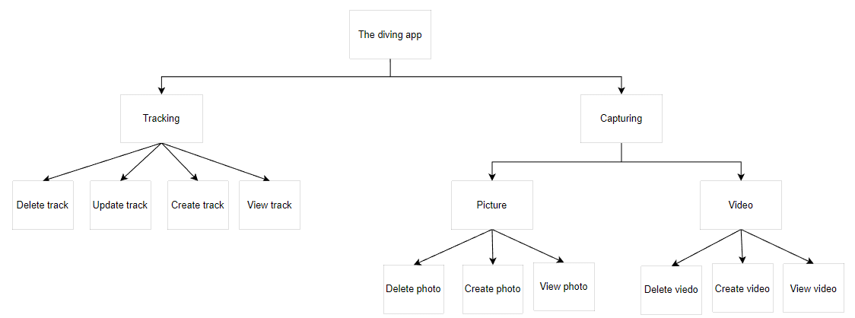

Figure 3 Hierarchical Model

* + 1. **Conceptual Model**

Figure 4 Conceptual Model

### Metaphors

|  |  |
| --- | --- |
| Icon | Description |
|  | Logout app |
|  | Take a photo |
|  | Start record |
|  | View library track |
|  | Navigate to the help page |
|  | Navigate to the setting page |
|  | Navigate to the connect page |
|  | Navigate to the terms and policies page |
|  | Navigate to the information page |
|  | Open popup |
|  | Swimming time |
|  | Edit information |
|  | Address |
|  | Water pressure |
|  | Depth |
|  | Temperature |
|  | Ascent time |
|  | List track |
|  | Lowest temperature |
|  | Maximum temperature |
|  | Precipitation rate |
|  | Sunny |
|  | Thunder |
|  | Cloudy |
|  | Some sunshine |
|  | Stop tracking |
|  | Play tracking |
|  | Pause tracking |

* 1. **Design principles**
     1. **Visibility**

The main functions of the application are displayed in easy-to-see places such as home page, track, list, profile.

Figure 5 Visibility

* + 1. **Feedback**

When a user performs a function, the feedback will be successful or unsuccessful. For example, when the register is successful and when then a tracking is successful.

* Register successful

Figure 6 Register successful

**Add track successful**

Figure 7 Add track successful

* + 1. **Constraints**

When a user wants to access the app, they must log in to the app. When a user performs the login function but does not enter complete information or enters the wrong username or password, the login function will fail.

Figure 8 Constraints

* + 1. **Consistency**

The colors of the application icons are designed in the same black color, it contrasts with the application background color, which makes it easier to see the necessary information.

Figure 9 Consistency

* + 1. **Affordance**

The main functions of the app, such as start diving, photographing and video recording, have been highlighted to stimulate user interaction.

Figure 10 Affordance

1. **Prototype**
   1. **Phycical prototype**

I have a physical prototype that helps protect the device well when operating underwater. The protective device has 3 buttons, it receives click events, consistent with the 3 buttons of up, down, volume and power off the phone. Regarding the phone's main interface, users can interact directly on the screen to use the application's functions.

This is a Phycical prototype interface that includes function buttons such as volume up, volume down and power off

Volume up button: click on the top to increase the volume

Volume down button: press the middle button to decrease the volume

Power off button: click the bottom to power off

Figure 11 Phycical prototype

* 1. **Low-fidelity Prototype**

The login interface consists of an avatart of the application, two fields for entering username, password, a login button and a hidden link to the register page.

Figure 12 Low-fidelity Prototype

* 1. **Mid-fidelity Prototype**

#### **Main page**

This is the phone interface, the Diving application has been installed, the user clicks to enter the scuba diving application

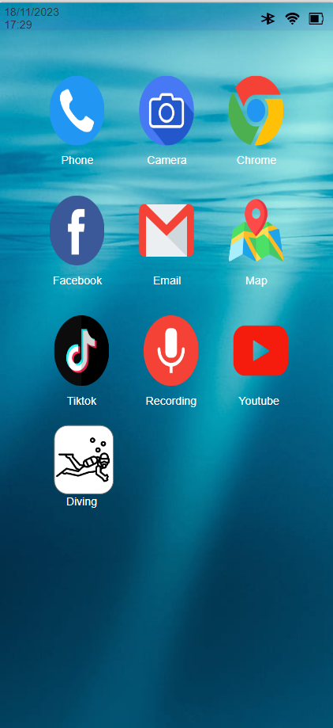

Figure 13 Main page

#### **Flash screen**

This is the flashcreen page of the application

Figure 14 Flash screen

#### **Login**

This is the login page of the application

When the user clicks on the login button, the following cases occur:

If no information has been entered, the error message "Password or user name empty" will appear.

When entering an incorrect username or password, the error message "Password or user name incorrect" will appear.

When entering the correct username and password, the application will navigate to the home page

#### **Register**

This is the application's registration page

When the user clicks on the register button, the following cases will occur:

If the information has not been entered, the error message "Please enter full information" will appear.

When entering the password and confirming password do not match, the error message "Password does not match" will appear.

When entering all information and the password matches. Notice "Register successfull"

Figure 15 Register

#### **Home page**

This is the app's home page of photos and videos of scuba diving

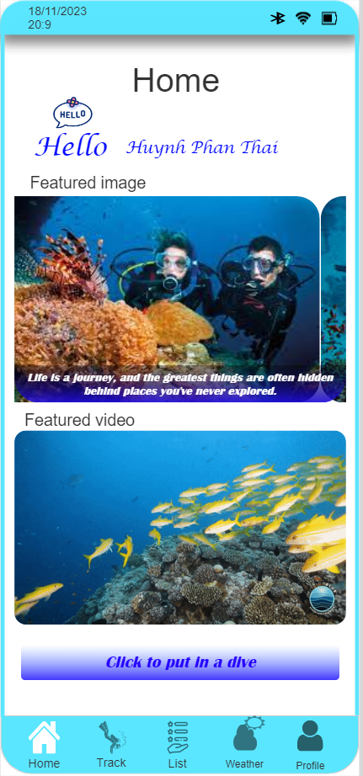

Figure 16 Home page

#### **Tracking**

##### **TrackPage**

This is the track interface. This page includes index information such as oxygen remaining in the tank, temperature, depth, water pressure. Besides, there are also functions such as:

Start scuba diving: When you click on the icon  . The application will navigate to the add informaion> page. Here the user can perform the function of adding information

Take a photo: When clicking on the icon.  The app will navigate to the add informaion page. Here the user can perform the take a photo function

Figure 17 TrackPage

##### **Add Track**

When the user clicks the Start diving button but does not enter the information, the error message "Please enter name and location". Conversely, the app will navigate to the home track page.

When tracking begins, users can take photos or record videos. When the button is clicked, the track will be saved and show Added Successfully

Figure 18 Add Track

Figure 19 Add Track(2)

##### **Update Track**

When clicking the button , a popup will pop up. The user clicks the button  to navigate to the update page. The user then enters information in the name and location fields, then clicks the upadate button to perform the update tracking function

Figure 20 Update Track(1)

Figure 21 Update Track(2)

##### **Delete Track**

When the person clicks the button. A popup will appear, the user clicks the button, next a dialog will appear, the user clicks the cancel button to cancel the function or OK to perform the delete function

Figure 22 Delete Track

##### **View Track**

When the user clicks the button , the app will navigate to the infor scuba page. This page shows all the information of a scuba diving trip

Figure 23 View Track

#### **Capture**

##### **Video**

When the user clicks the button, the app will navigate to the Record page. Users click on the icon  to start the record, click on the icon  to save the video

Figure 24 Record

Figure 25 Record((2)

##### **Picture**

When the user clicks the button , the app will navigate to the capture page. Users click on the icon  to start the capture

Figure 26 Take a photo

##### **View picture and video**

When the user clicks on the icon, the application will navigate to the photo and video save page. Here users can view information of each video, picture or delete it.

Figure 27 View picture and video

##### **Delete**

When the user clicks on the icon, a dialog box will appear, the user clicks the cancle button to cancel or the ok button to perform the delete function

Figure 28 Delete

##### **View detail picture or video**

When the user clicks the icon, the app will navigate to the infor observation page, where the user can view photos or videos and details when performing the capture and video functions.

Figure 29 View detail picture or video

#### **Search scuba diving**

##### **Search normal**

When the user clicks on the icon , a field will appear. When the user enters the name scuba diving wants to search. If the name entered is close to the same or similar, it will show up in the list.

Figure 30 Search normal

##### **Search advanced scuba diving**

When the user clicks on the icon , một hộp thoại sẽ xuất hiện . Khi người dùng nhập dữ liệu vào các field và nháy vào icon . If the entered data is similar or similar, it will show up in the list.

Figure 31 Search advanced scuba diving

#### **Weather**

This page is a weather page, users can see weather information from Monday to Sunday here, when users click on a box from Monday or Sunday, it will display detailed information above

Figure 32 Weather

#### **Profile**

This page is a profile page, used to display user details and a setting function. When the user clicks on the icon , the application will navigate to the settings page base.

Figure 33 Profile

#### **Setting**

This page is the settings page, containing functions such as: connect, terms and policies, help and logout

##### **Connecting**

, the application will navigate to the nonnect page. Here users can turn on/off bluetooth or wifi

Figure 34 Connecting

##### **Terms and policies**

, the application will navigate to the nonnect page. Here will display the application's terms and policies.

Figure 35 Terms and policies

##### **Help**

Help: when clicking on the box , the application will navigate to the help page. Here will show how to use the app more effectively

Figure 36 Help

##### **Logout**

. A dialog box will appear. When the user clicks the cancel button, the logout function will be canceled. Conversely, when clicking the OK button, the logout function will be performed

Figure 37 Logout

1. **Research Study**

When I developed a professional diving application, I discovered the following:

Hypothesis: Users need a device with a modern, easy-to-use interface. It takes a lot of functionality to be able to recognize the current environment and save many interesting moments.

When I joined many diving communities, I found that the age of most participation was between 25 and 45. So my research target will be those people.

Participants will answer qualitative and quantitative questions on the subject of scuba diving.

The answers will be analyzed statistically to develop a complete approach from interface to function.

Participants' survey responses will be gathered for this study using Google Forms, enabling further research and application development.

According to research from the answers of question 1. The results of diving have a very good effect on the mind, helping to relax the mind, feel more alert and reduce stress.

According to research from the answers of question 2. People who often come to scuba diving are inspired by the community. A community passionate about scuba diving will influence many people, creating a passion for others

According to research from the answers of question 3. According to research from the answers to question 3. Most people have a hobby of exploring new places, and they are also people with a lot of experience.

According to research from the answers to question 4. Safety issues that should be paid attention to in scuba diving equipment are: emergency signaling devices such as emergency lights or gps devices.

According to research from the answer to question 5. Everyone is looking forward to having new equipment, and often updates information on scuba diving forums.

According to research from the answer to question 6. People have an average of 4 scuba diving trips every year

According to research from the answer to question 7 . On average, 60% of people's scuba diving trips use smart devices.

According to research from the answers to question 8. On average, 50% of people are quite concerned about safety when scuba diving.

According to research from the answer to question number 9. On average, 50% of people scuba dive in difficult conditions

According to research from the answer to question number 10. On average, 40% of scuba divers like to dive at night

The designs are based on heuristic methods

|  |  |
| --- | --- |
| Heuristic methods | Mid-fidelity prototype |
| Visibility of system status | When successfully performing the "Add scuba diving" function. The Add Successful message will display to notify the user that the add was successful |
| Match between the system and the real world | The icons represent functions for easy recognition |
| User control and freedom | Dialog boxes appear to confirm information, avoiding unwanted occurrences |
| Consistency and standards | Always use icons  to delete information  Use icon to perform  update function  Use icon to perform  information viewing function |
| Error prevention | When there is an error in input data, a message will be displayed to help users easily identify it |
| Recognition rather than recall | The pause and stop icons are found in many applications so users can easily recognize them |
| Flexibility and efficiency of use | The add function is placed on the first page to help create a new diving trip quickly if the user does not want to switch pages. |
| Aesthetic and minimalist design | A video or picture information box only displays the most necessary and interesting information and functions, avoiding redundancy of information. |
| Help users recognize, diagnose, and recover from errors | Bind functions, only when the user is logged in can use other functions of the app |
| Help and documentation | Helpful help when users want to learn about the app |

1. **Conclusion**

The project has the potential to develop a more social network for diving communities to communicate with each other. Functionally, we can develop a number of body index measurements, because we can only monitor external indicators like oxygen, depth, sea temperature, but we can't measure internal indicators such as heart rate, body temperature. Besides, it is recommended to have a radar function, search for the nearby divers, send them a call for help.

# References

DiveMate. (2020). DiveMate (Scuba Dive Log). p. https://play.google.com/store/apps/details?id=com.confitek.divemateusb&hl=en.

Dykusha, D. (2021). Diving logbook-Dive Number. pp. https://apps.apple.com/us/app/diving-logbook-dive-number/id949480835?ls=1.

Garmin. (2020). Garmin Dive™. p. https://play.google.com/store/apps/details?id=com.garmin.android.apps.dive&hl=en&gl=US.

Henderson, J. a. (2002). *interactions*. Retrieved from https://interactions.acm.org/archive/view/january-2002/conceptual-models1

Jacko, J. A. (2009). *Human-Computer Interaction. Novel Interaction Methods and Techniques.*

Jacko, J. A. (2009). *Human-Computer Interaction. Novel Interaction Methods and Techniques.*

Kanade, V. (2022, July 22). What Is HCI (Human-Computer Interaction)? Meaning, Importance, Examples, and Goals. *What Is HCI (Human-Computer Interaction)? Meaning, Importance, Examples, and Goals*, pp. https://www.spiceworks.com/tech/artificial-intelligence/articles/what-is-hci/.

Nirmalya Thakur, P. B. (202). *human-Computer Interaction and Beyond.*

Rogers, P. a. (2009). *Interaction Design: Beyond Human-computer Interaction.*

Rogers, Y. (2022). *HCI Theory: Classical, Modern, and Contemporary.* Yvonne Rogers.

Seffah, A. (2015). *Patterns of HCI Design and HCI Design of Patterns.*

Stuart K. Card, T. P. (2000). *The Psychology of Human-Computer Interaction.* Stuart .

Valverde, D. R. (2011). *Principles of Human Computer Interaction Design: HCI Design.*

# **Appendices**

https://docs.google.com/forms/d/e/1FAIpQLScdBBmUDyFXMA7AryqEJDpgr3WHsDN2tA3eu0PNCluqghOQ3g/viewform

